Setting up ActiveSync Mail

iPhone/iPad

On an iPhone go to Settings 🡪 Mail, Contacts, Calendar 🡪 Add Account 🡪 Exchange

Enter the users email address, password and a description for the mailbox.

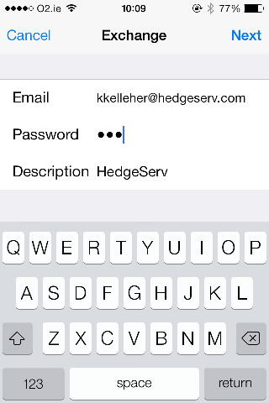

Click on Next

It will fail to find the account and will look for more information. In the next screen type the server name (hsmob.hedgeserv.com), the domain (fds) and the user’s username and password.

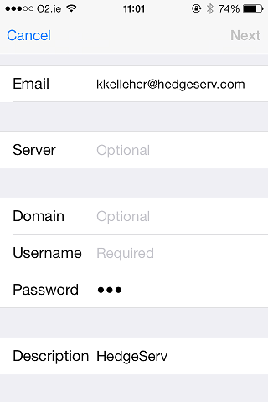

Click on next and choose the settings they need synced. Then hit Save.

Android

Go to Settings 🡪 Acocunts 🡪 Add account 🡪 Microsoft Exchange ActiveSync 🡪 Manual

Enter in the requested information and click on Next

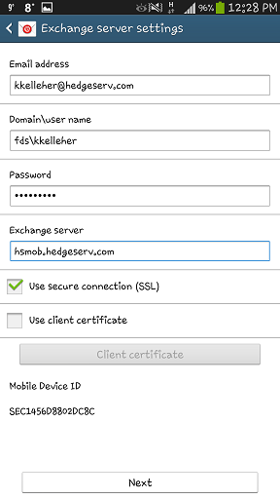

Accept the Activation and Remote security administration prompts.

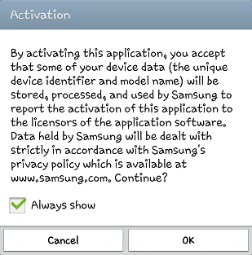

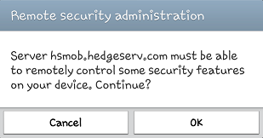

On the next screen click activate, this will allow remote wiping of the phone in the event it is lost or stolen

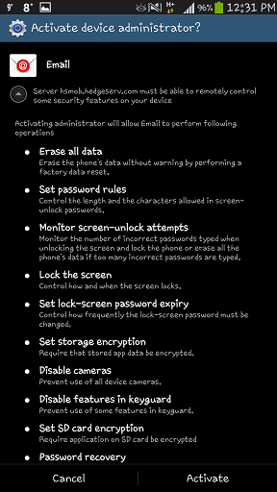

On the final screen give the mailbox a name (optional)

